*Step 1*: Import the Excel sheet named " House Price" and click on Transform Data.

*Step 2*: In the **House Price** table, remove top 2 rows as they contain null values using **remove rows --> remove top rows**. A pop-up appears, write 2 and this will remove the top 2 rows.

*Step 3*: Now use top row as header, in the transform section under home tab in power query editor for both the tables.

*Step 4*: Now, **Remove rows --> Remove errors**. Then change the type of "**Handover Date**"  to Date/Time. Finally, click on Close and apply.

*Step 5*: Go to the Model view and create connections manually between the 2 tables.

*Step 6*: In the report view, create a table with Handover Date, PostCode, Location, SalesPrice, Property type.

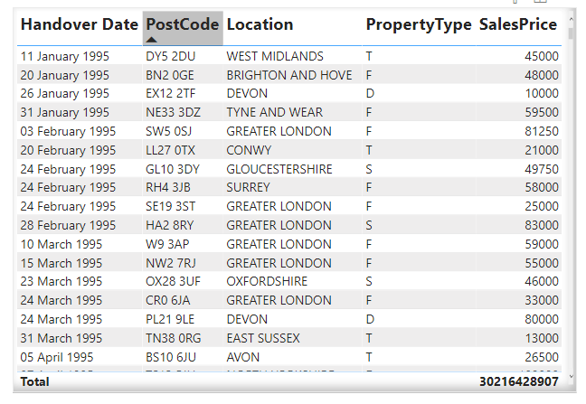

Report created

*Step 7:* Now, Go to report view --> Modelling --> Manage roles. A pop-up window appears. The DAX expressions can be used as:

• **[PropertyType] = "D"**

• **[PropertyType] = "F"**

• **[PropertyType] = "O"**

• **[PropertyType] = "S"**

• **[PropertyType] = "T"**

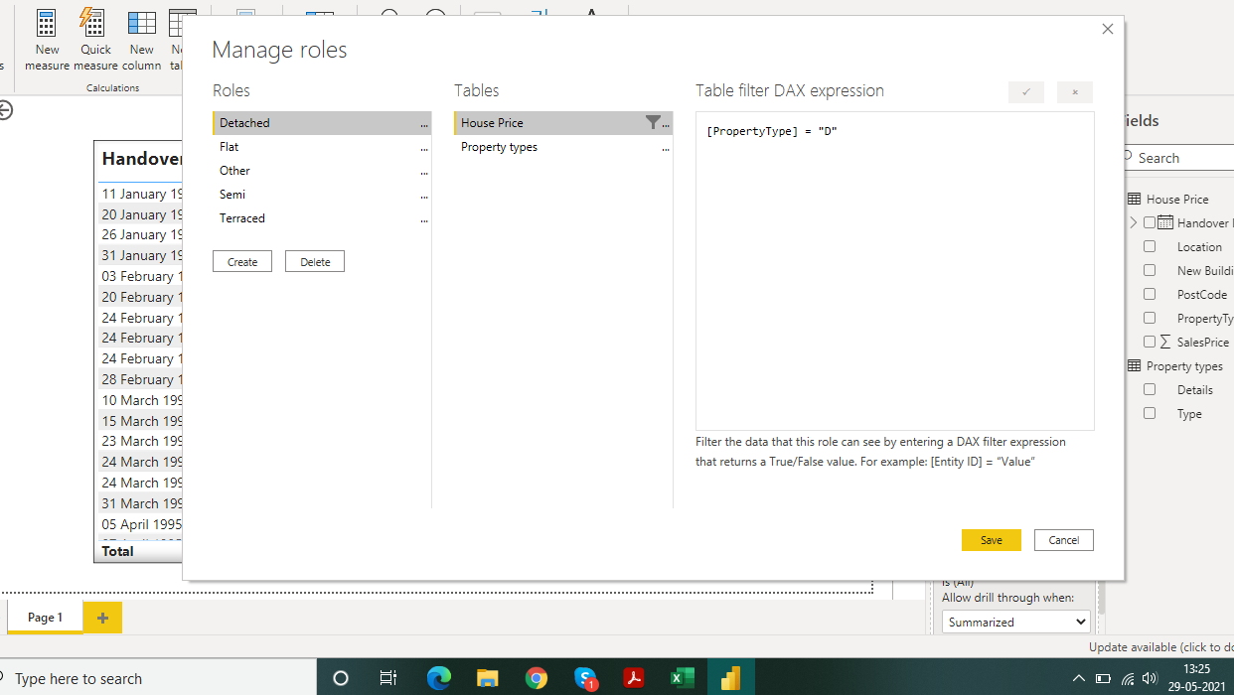

Creating the Role under Manage roles section

*Step 8*: Now the roles are created, we need to view them. For this, Modelling --> View as. Select one among the 5 roles and view.

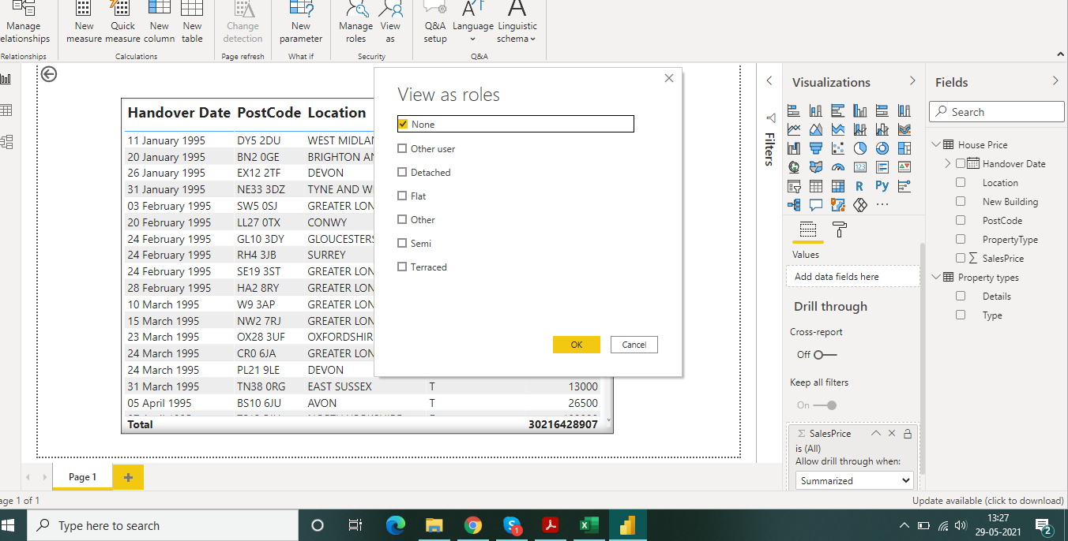

Test a role under View As section

*Now we need to publish the report on powerBi service. For that we need to have a professional mail id.*

*Step 9*:

• For publishing the report, we need to save it in ".pbix" format and then, Report view --> Home --> Publish.

• Select the destination as "My Workspace" in the pop-up that appears. After the report is published, we will get a pop-up like this:

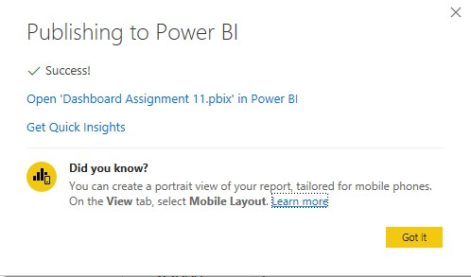

Pop-up when the report is successfully published in PowerBI service

*Step 10:* In the Workspace, we have options like Reports, Datasets etc. Go to dataset and there we will find our dataset. Click on the 3 dots (⫶) beside our dataset, then security. Add email ids for the 5 roles available and click on save. Now, on the 3 dots (⫶) beside the roles, we have the option to test the view.

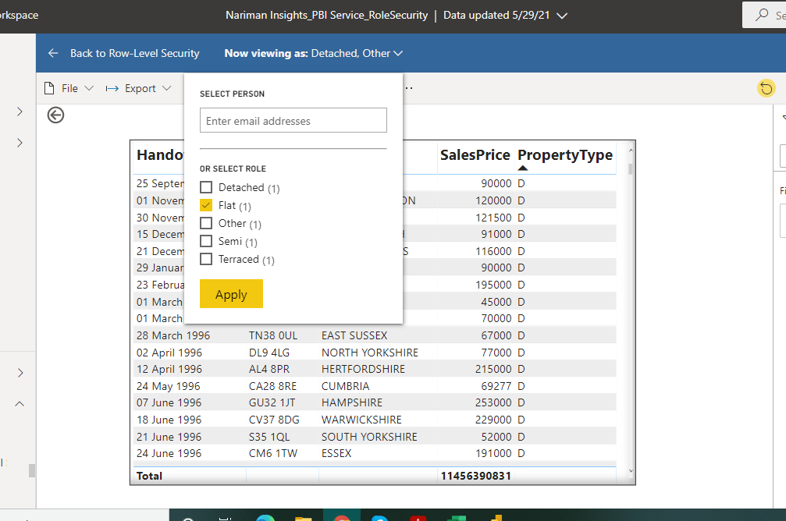

Select Role

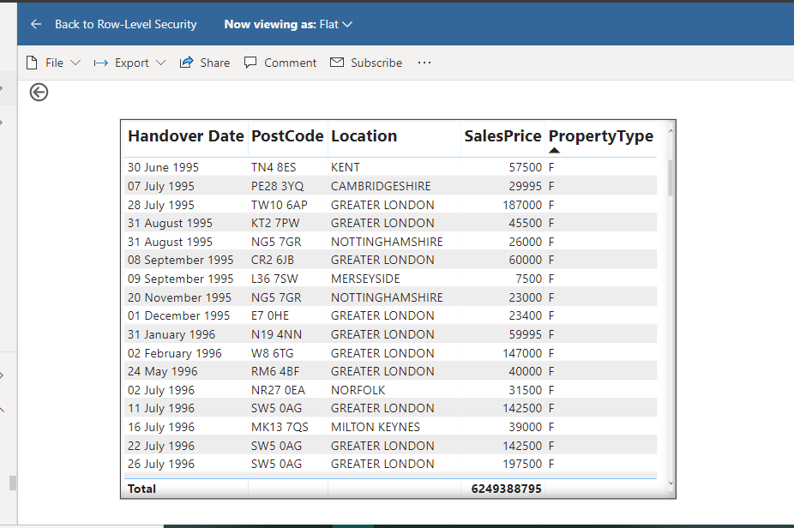

View of the role "Flat"

*Similarly we can verify for all the 5 types of roles.*